Task 4

4. JavaScript in JSX with Curly Braces

Tasks:

1. Display today’s date in a component using the JavaScript Date object.

**TodayDate.jsx**

import React from 'react'

export default function TodayDate() {

const TodayDate = new Date().toLocaleString()

return (

<>

<h3>{TodayDate}</h3>

</>

)

}

**Main.jsx**

import TodayDate from './TodayDate.jsx'

createRoot(document.getElementById('root')).render(

<StrictMode>

<TodayDate />

</StrictMode>

)

**Output**

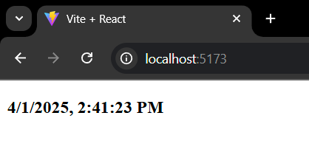

2. Create a component that displays a random quote from a hardcoded list of

quotes.

**RandomQuote.jsx**

import React from 'react'

export default function RandomQuote() {

const quotes = ['If you are going through hell, keep going.','If you build it, they will come.','If you want something done right, do it yourself.','If you want something said, ask a man; if you want something done, ask a woman.']

return (

<>

<h2>RandomQuote</h2>

<p>{quotes[Math.floor(Math.random()*quotes.length)]}</p>

</>

)

}

**Main.jsx**

import RandomQuote from './RandomQuote.jsx'

createRoot(document.getElementById('root')).render(

<StrictMode>

<RandomQuote />

</StrictMode>

)

**Output**

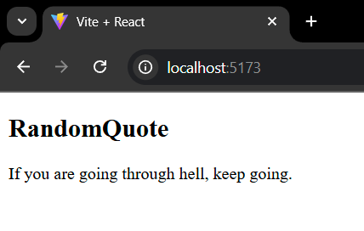

3. Write a component called MathResult that displays the result of a simple

arithmetic operation (e.g., addition) of two hardcoded numbers.

**MathResult.jsx**

import React from 'react'

export default function MathResult() {

const a = 5

const b = 10

return (

<>

<h3>The addition of {a} and {b}:</h3>

<h2>{a+b}</h2>

</>

)

}

**Main.jsx**

import MathResult from './MathResult.jsx'

createRoot(document.getElementById('root')).render(

<StrictMode>

<MathResult />

</StrictMode>

)

**Output**

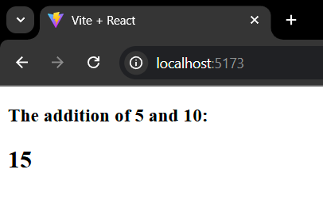

4. Create a component that displays the word count of a hardcoded paragraph.

**Paragraph.jsx**

import React from 'react'

export default function Paragraph() {

const para = "React is a JavaScript library primarily used for building user interfaces (UIs) for web applications"

return (

<>

<h3>{para}</h3>

<h2>{para.split(" ").length}</h2>

</>

)

}

**Main.jsx**

import Paragraph from './Paragraph.jsx'

createRoot(document.getElementById('root')).render(

<StrictMode>

<Paragraph />

</StrictMode>

)

**Output**

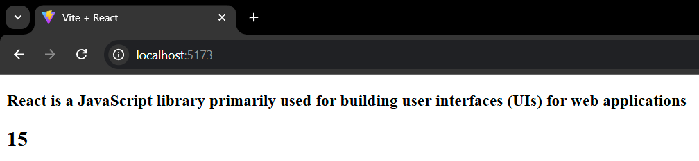

5. Create a component that calculates and displays the product of two

hardcoded numbers.

**Product.jsx**

import React from 'react'

export default function Product() {

const a = 5

const b = 10

return (

<>

<h3>The product of {a} and {b}:</h3>

<h2>{a*b}</h2>

</>

)

}

**Main.jsx**

import Product from './Product.jsx'

createRoot(document.getElementById('root')).render(

<StrictMode>

<Product />

</StrictMode>

)

**Output**

